**Jewelry Inventory Management System**

**Swarnandhra College of Engineering and Technology , Narsapur**

**Team ID:** LTVIP2025TMID30526

**Team Members Details:**

|  |  |
| --- | --- |
| **S.No** | **Name of the Student** |
| **1** | Sola Gopichandu |
| **2** | Satya Nani Koruprolu |
| **3** | Y Anil Kumar |

**Salesforce Project Documentation**

# Project Title:

CRM Application for Jewelry Inventory Management System

# Project Description:

This project aims to enhance the efficiency of managing jewelry store operations using Salesforce. The system centralizes customer, gold/silver item records, pricing, and billing information. It reduces manual errors by automating price calculations based on purity, weight, and item type. The application ensures secure role-based access for store admins and workers, implements validation logic to maintain data accuracy, and provides visual dashboards for performance tracking and item analysis.

# Project Objectives:

* Consolidate customer, item, and billing data within one Salesforce application
* Assign roles and responsibilities for store staff
* Record and track gold/silver items with attributes like purity, type, and weight
* Auto-calculate total price based on purity and weight
* Generate invoices and billing reports
* Automate calculations using flows and Apex triggers
* Ensure data integrity with validation rules
* Provide dashboards for daily revenue and stock status

# Project Features:

* Lightning App interface for centralized jewelry management
* Custom objects for Customer, Item, Billing, and Pricing
* Assign item type, purity, and weight through user-friendly interfaces
* Auto-calculate price using formula fields and Apex triggers
* Automate updates using Flows
* Ensure valid data using Validation Rules
* Create summary reports for item trends and customer billing
* Dashboard for revenue, item stock, and top-selling items
* Role-based access control using profiles and permission sets

# Project Flow & Milestones:

### Salesforce Account

Created a Salesforce Developer Org to begin the Jewelry Inventory App setup.

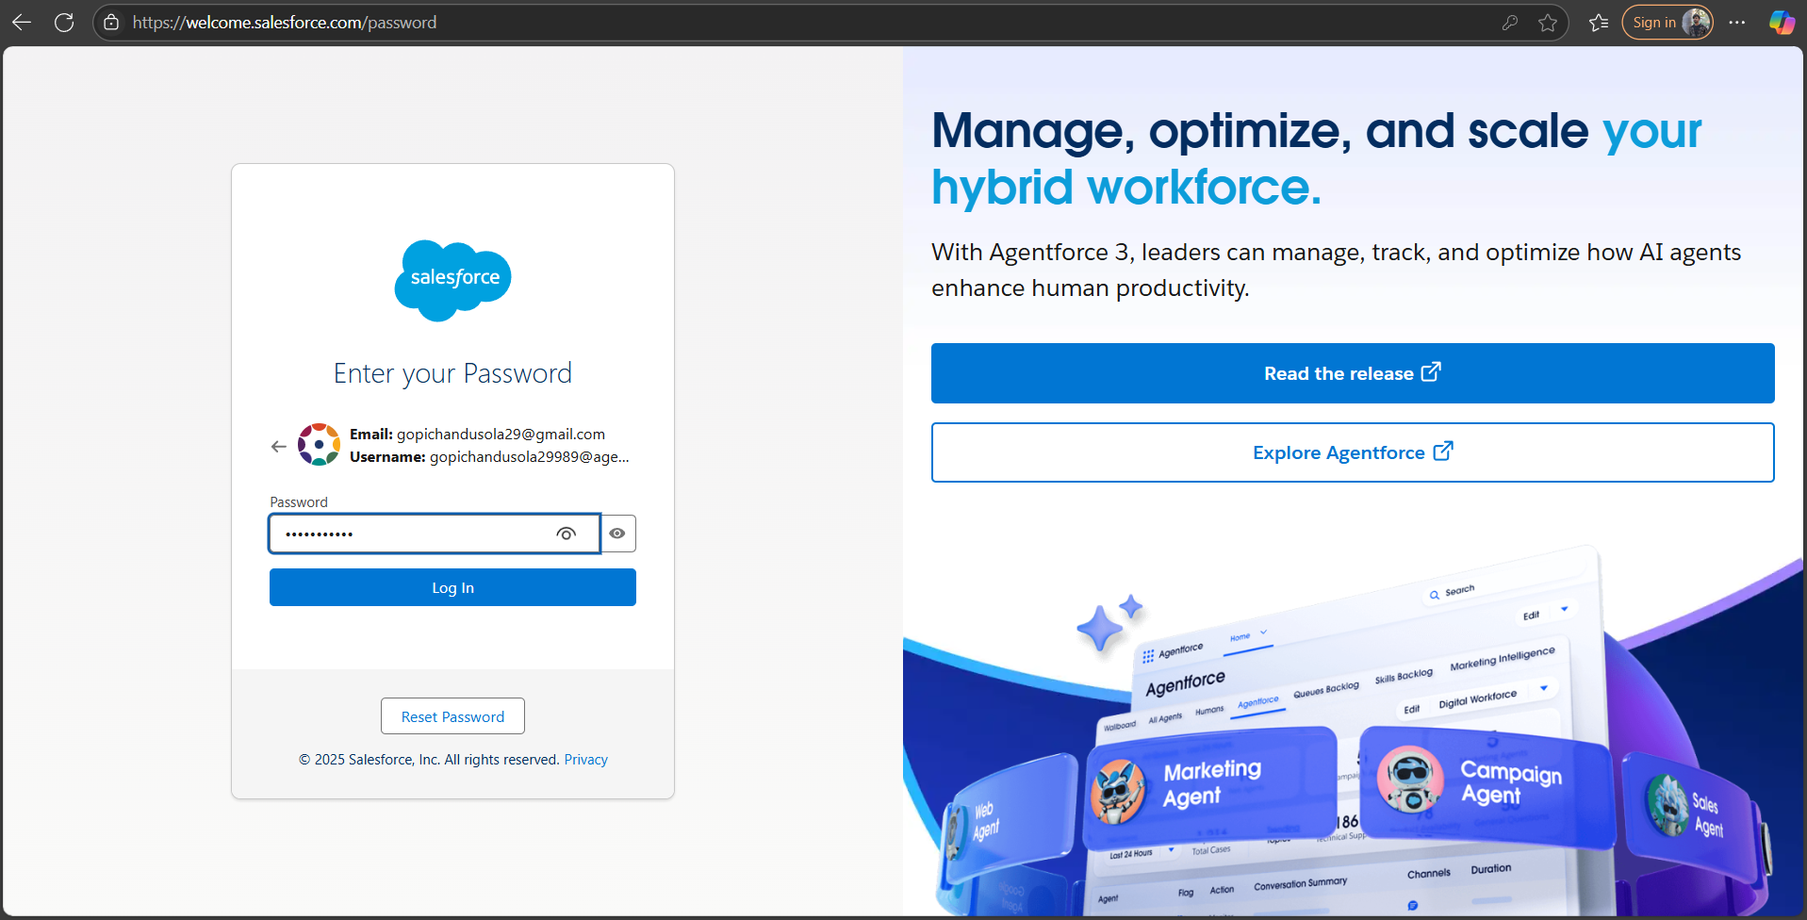

### Objects

Custom objects created: Jewel_Customer__c, Gold_Silver_Item__c, Billing__c, Pricing__c

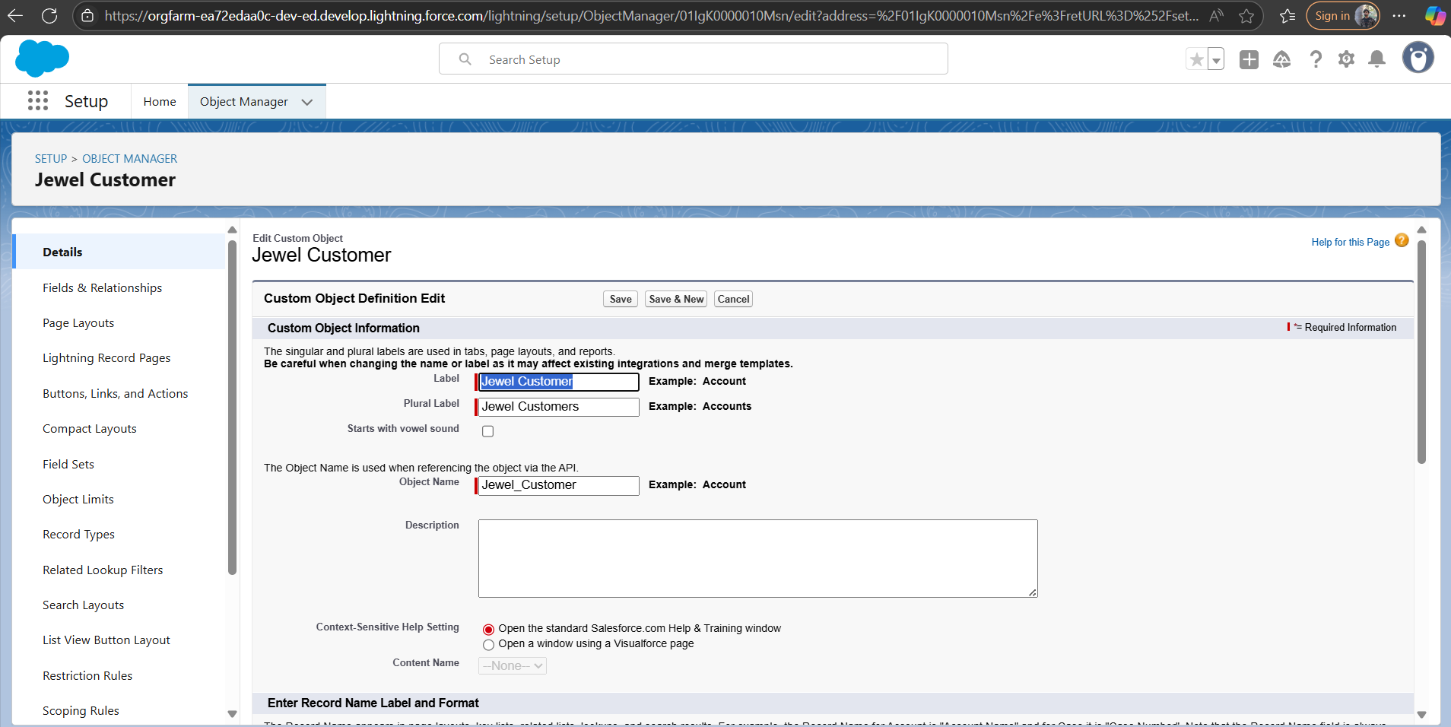

**Tabs**

Tabs were created for each object to simplify navigation.

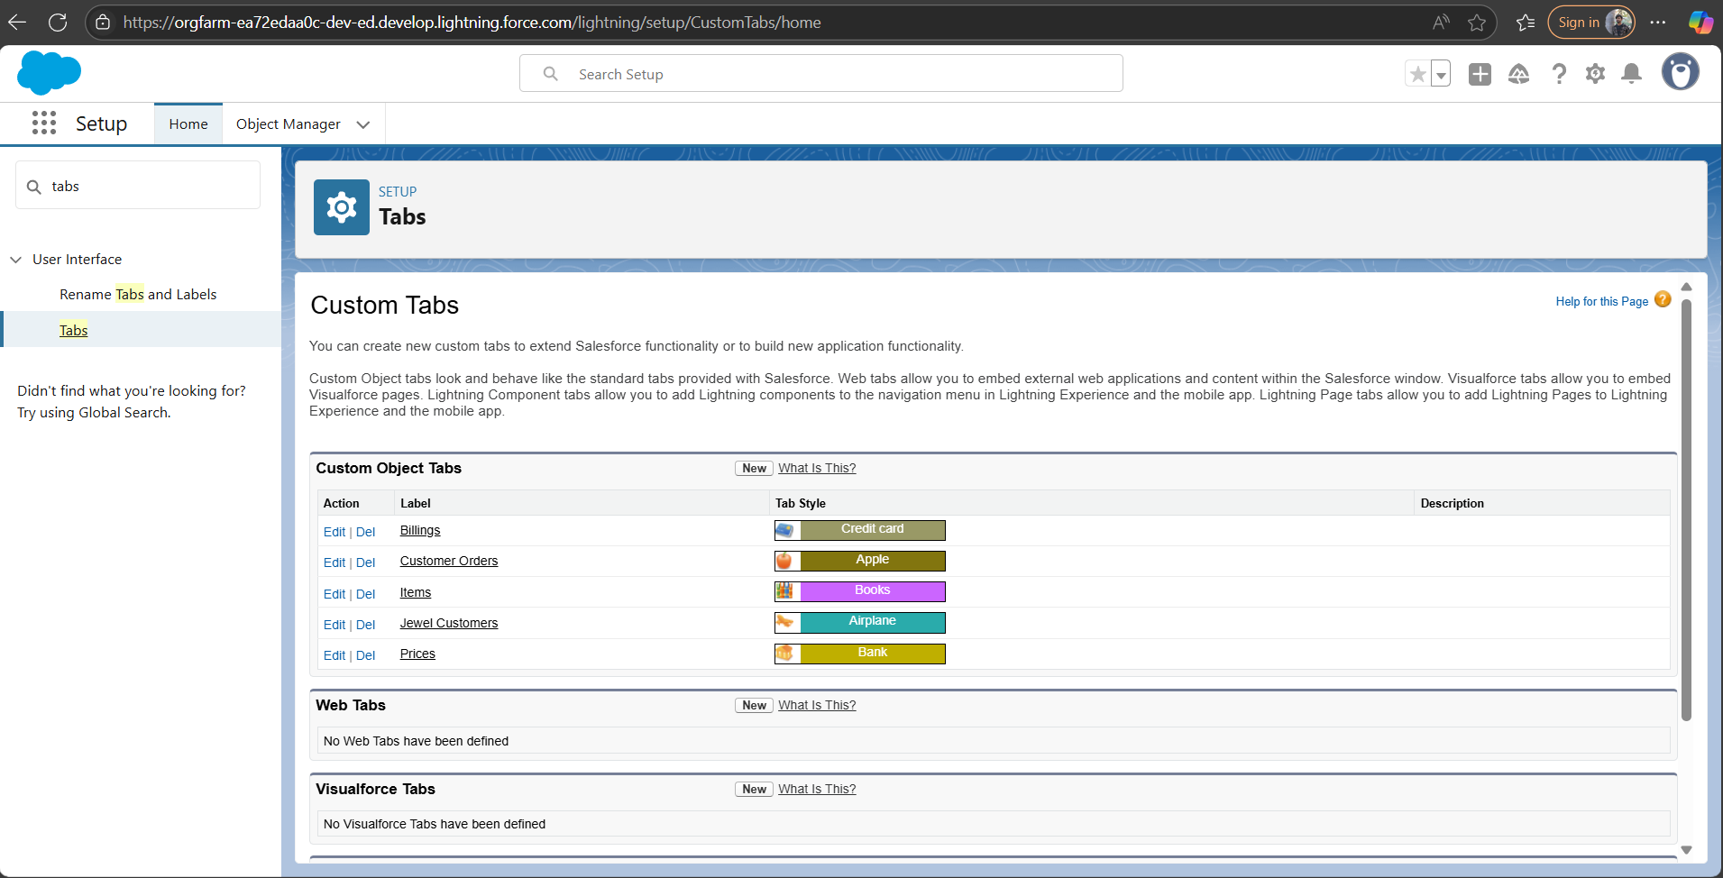

### The Lightning App

Developed a Lightning App called “Jewelry CRM” for managing the full inventory workflow.

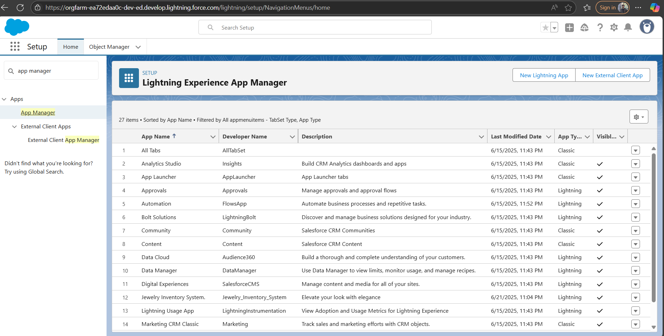

### Fields

Added fields like Purity (%), Item Type (Gold/Silver), Weight (grams), Price per gram, and Total Price (calculated using formula).

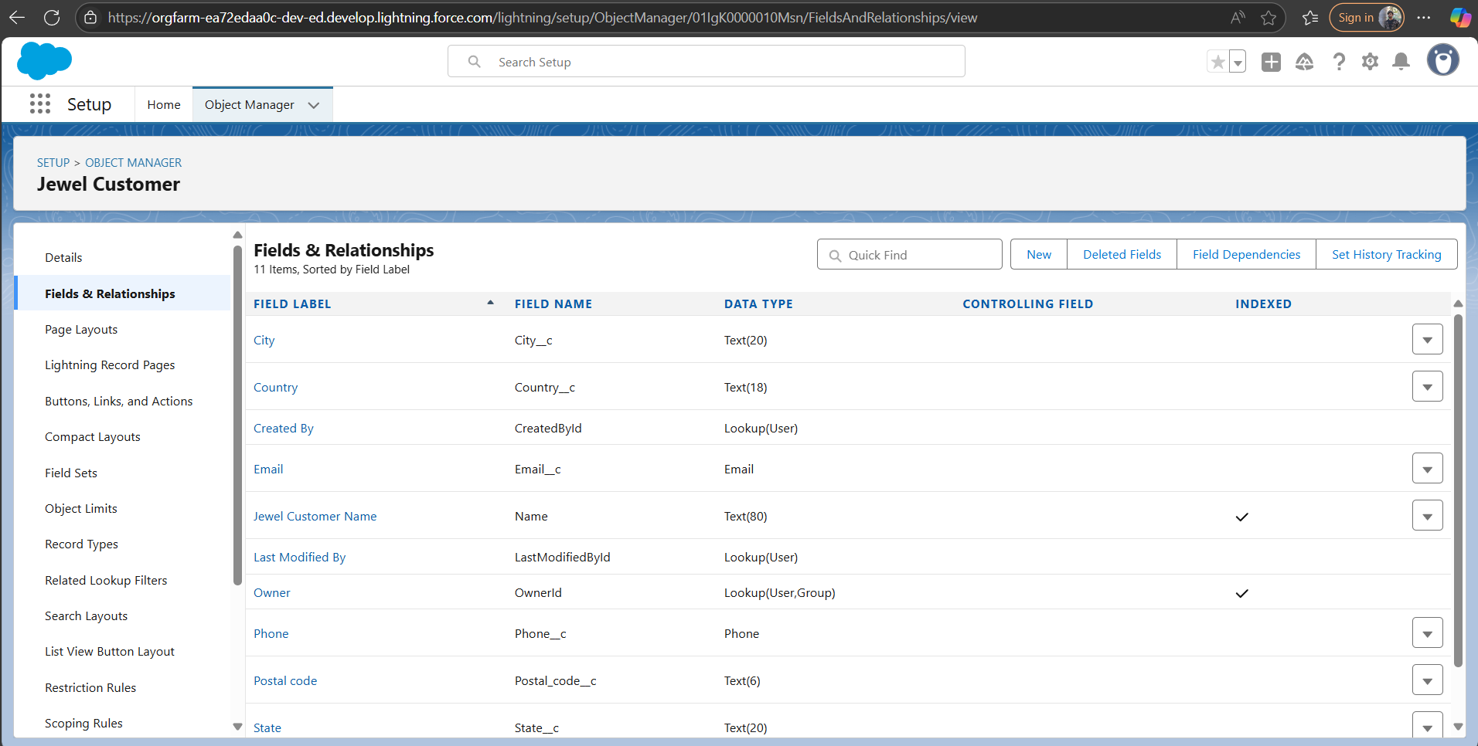

### Page Layouts

Custom page layouts designed to show only necessary fields to each user type.

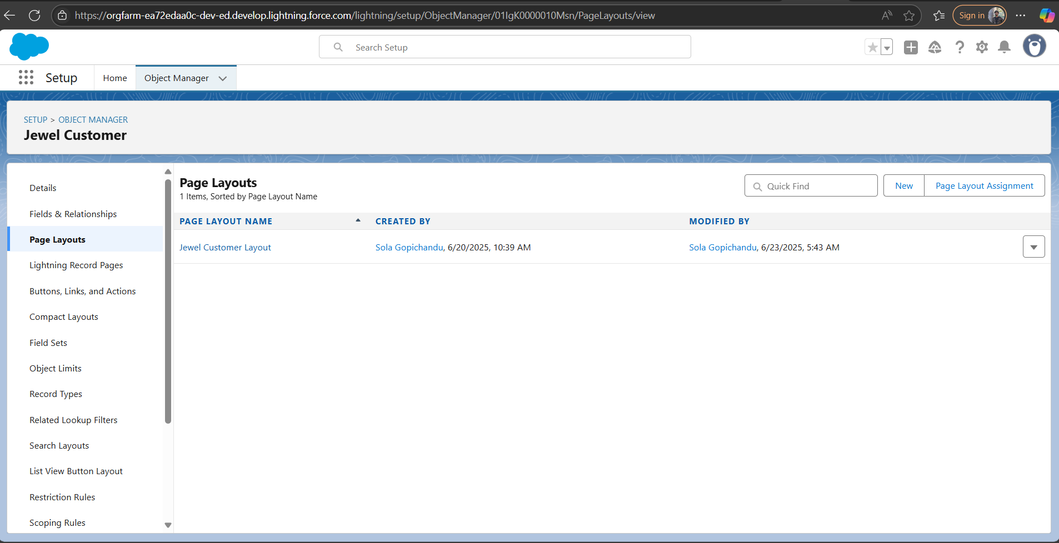

### Validation Rules

Applied rules to validate input ranges (e.g., purity between 50–100%, weight > 0g).

### 

### Flows

Flows created to automate: Price calculations, Age & retirement date (for staff, if applicable), Record updates based on item type or category.

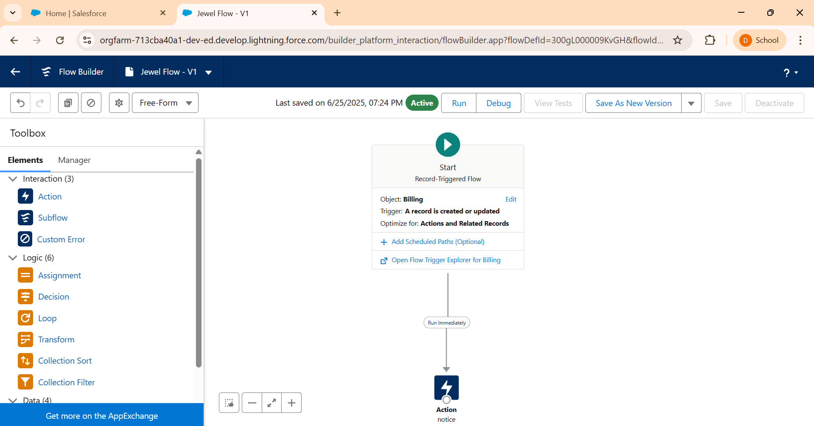

### Triggers

Created Apex Trigger to automatically update Paid_Amount when Total_Price is calculated.

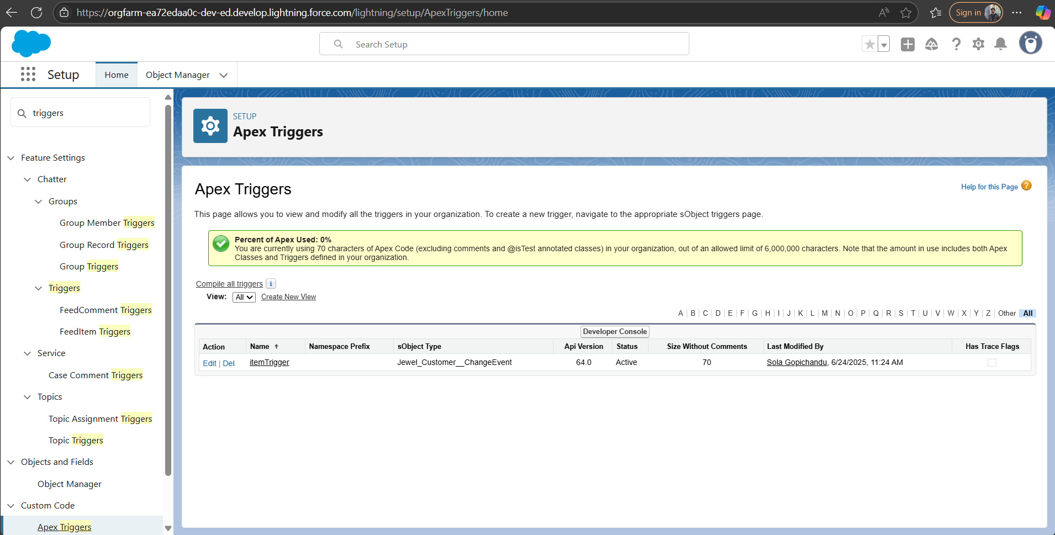

### Reports

Reports generated: Items Sold by Date, Revenue by Item Type, Customer Billing Summary

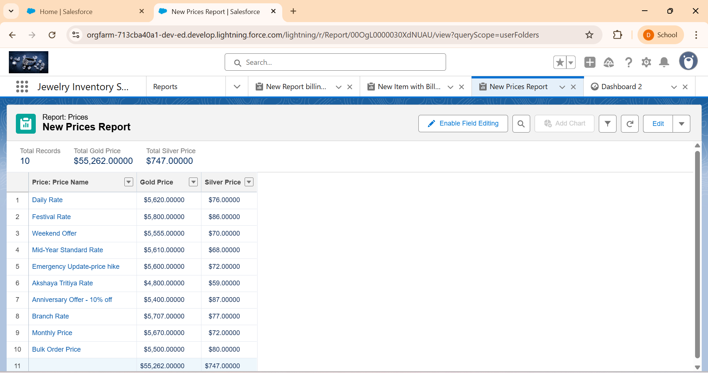

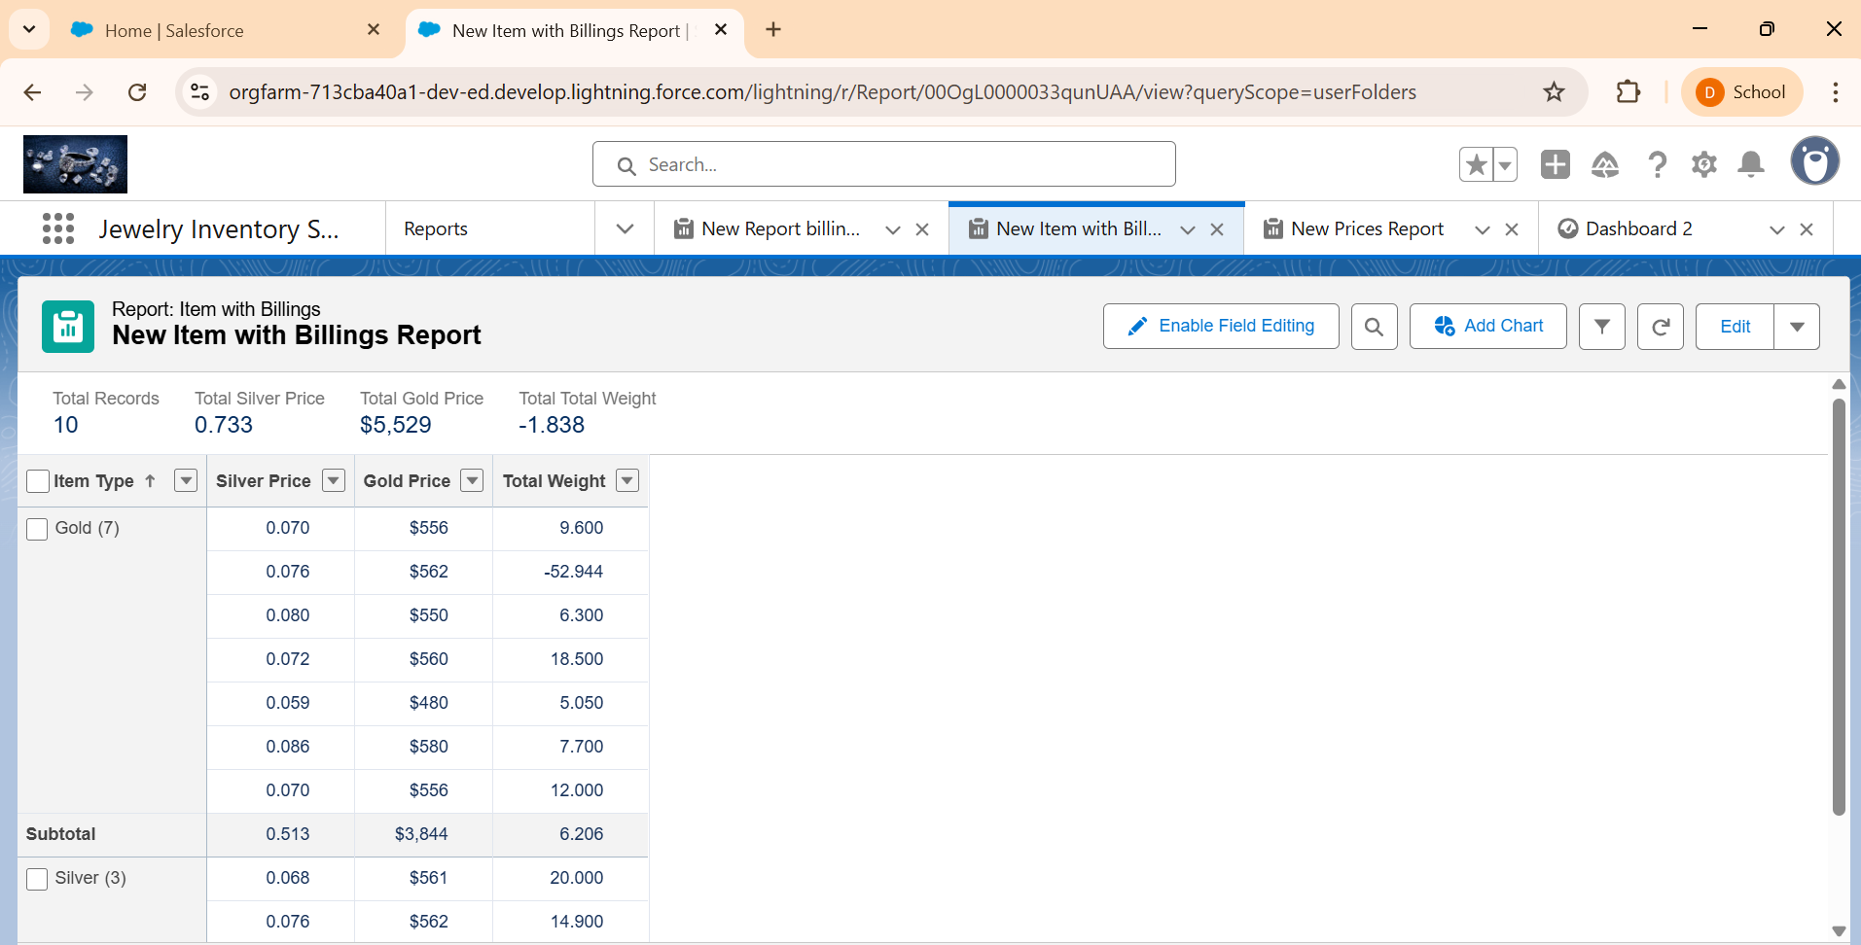

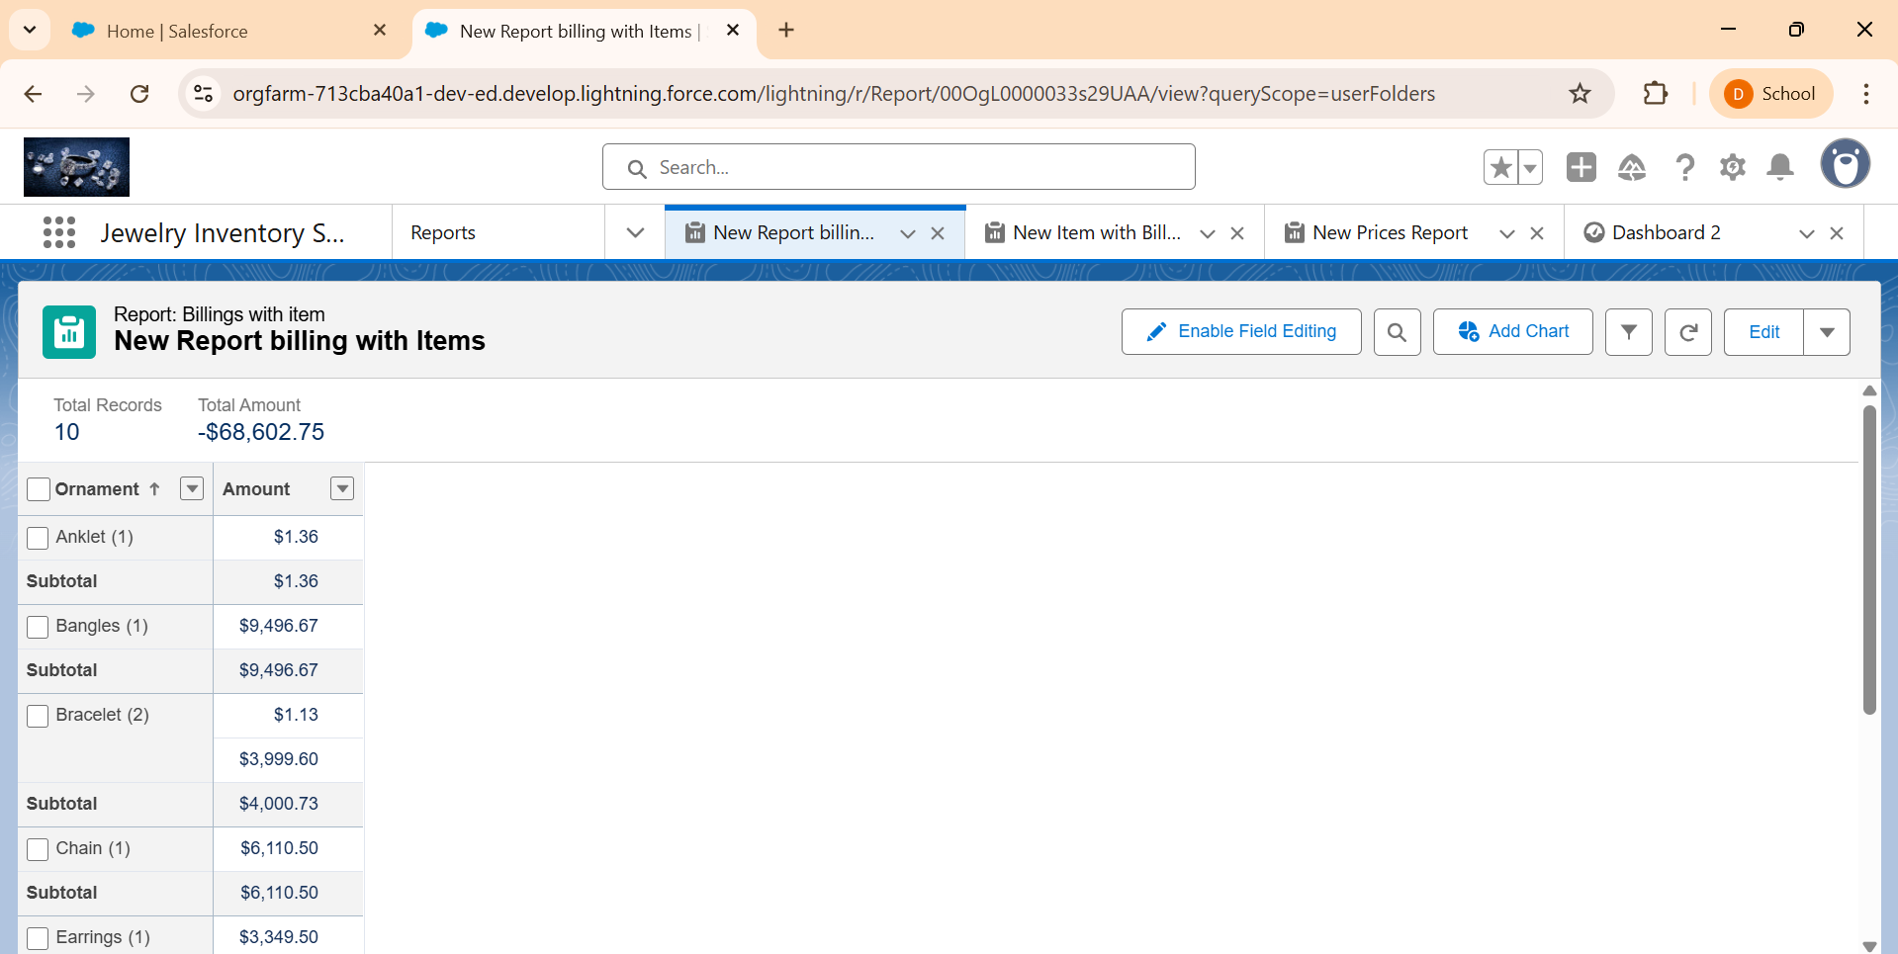

### Dashboards

Dashboards display: Total daily revenue, Top-selling items, Stock left by item type

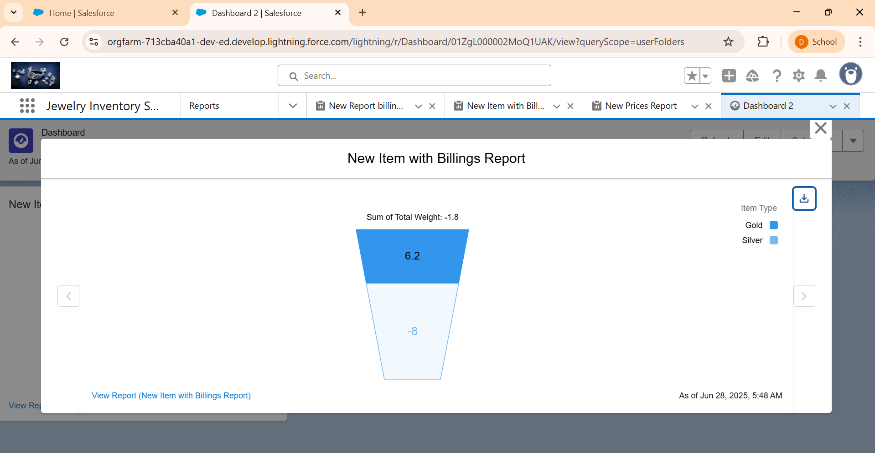

### Final Output:

An interactive, role-based CRM application to manage customer data, item details, pricing, billing, and reporting – all through a user-friendly Salesforce interface.

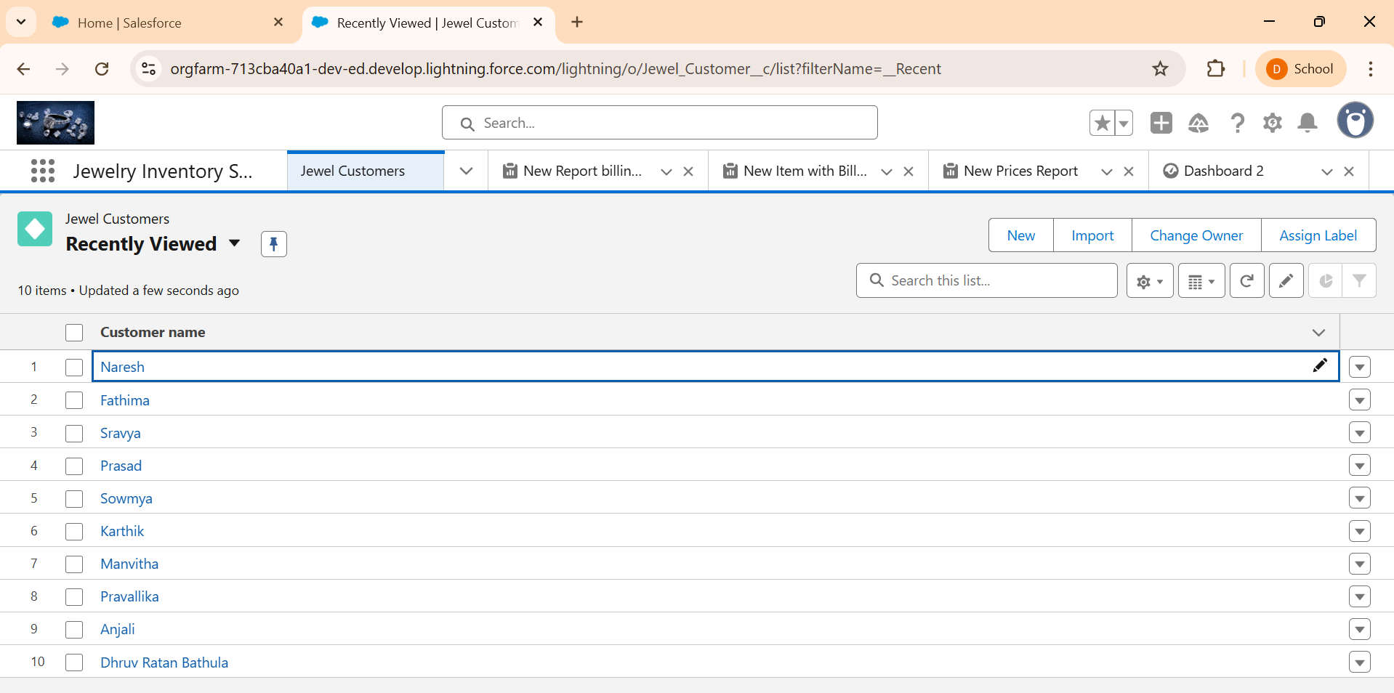

# Technologies & Tools Used:

* Salesforce Lightning Platform
* Apex Triggers
* Salesforce Flows
* Validation Rules
* Reports & Dashboards
* Roles, Profiles, and Permission Sets

# Learning Outcomes:

* Mastery of Salesforce object modeling and field creation
* Experience in automation with Apex and Flows
* Strong understanding of validation rules and page layout customization
* Skill in building meaningful dashboards and reports
* Implementing secure user access through roles and permissions

# Conclusion:

The **Jewelry Inventory CRM Application** provides a robust, automated, and secure platform for managing jewelry operations. It simplifies inventory tracking, billing, and pricing processes while improving data accuracy and decision-making with dashboards and reports. The system’s automation capabilities significantly reduce manual efforts and errors, making it an ideal solution for modern jewelry businesses.